# 

BÁO CÁO LAB 5

MOB305 – GAME 2D

GVHD: Bùi Minh Nhựt

Sinh viên thực hiện: Nguyễn Văn Lâu

MSV: PS03784

Lớp: PT11105

# Giao diện Game:

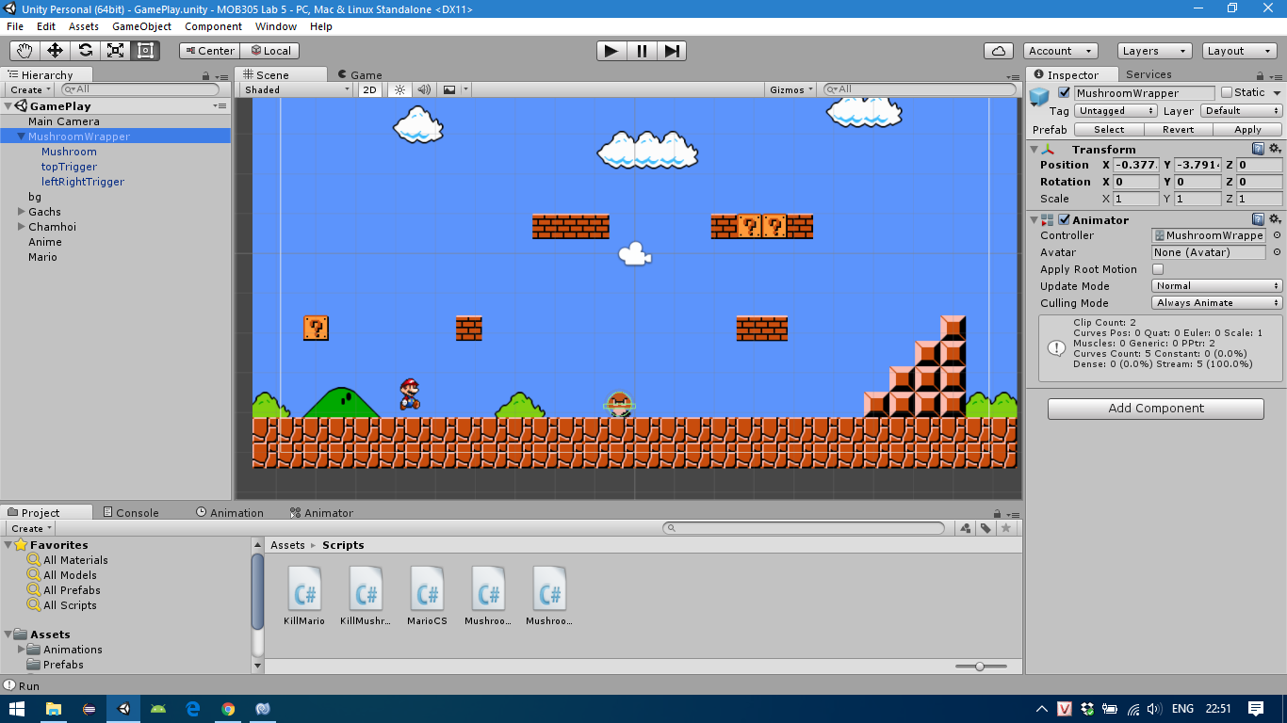

# Code Mario Run:

using UnityEngine;

using System.Collections;

public class MarioCS : MonoBehaviour {

public float speed;

public float jumpSpeed;

private Animator animator;

// Use this for initialization

void Start () {

animator = transform.GetComponent<Animator> ();

}

// Update is called once per frame

void Update () {

if (Input.GetKey (KeyCode.RightArrow)) {

if(transform.localScale.x < 0){

transform.localScale = new Vector3 (3, 3, 0);

}

transform.Translate (Vector3.right * speed * Time.deltaTime);

}

if (Input.GetKey (KeyCode.LeftArrow)) {

if(transform.localScale.x > 0){

transform.localScale = new Vector3 (-3, 3, 0);

}

transform.Translate (-Vector3.left * speed * Time.deltaTime);

}

if (Input.GetKey (KeyCode.Space)) {

transform.Translate (Vector3.up * jumpSpeed * Time.deltaTime);

}

if (Input.GetKey (KeyCode.RightArrow) || Input.GetKey (KeyCode.LeftArrow)) {

animator.SetBool ("isRun", true);

animator.SetBool ("isIdle", false);

} else {

animator.SetBool ("isRun", false);

animator.SetBool ("isIdle", true);

}

}

}

# Code Mushroom Run:

using UnityEngine;

using System.Collections;

public class MushroomRun : MonoBehaviour {

// Use this for initialization

void Start () {

print ("Run");

}

// Update is called once per frame

void Update () {

transform.Translate (Vector3.left * Time.deltaTime);

}

}

# Code Kill Mario:

using UnityEngine;

using System.Collections;

public class KillMario : MonoBehaviour {

// Use this for initialization

void Start () {

print ("Kill Mario");

}

// Update is called once per frame

void Update () {

transform.Translate (Vector3.left * Time.deltaTime);

}

void OnTriggerEnter2D(Collider2D other){

if(other.gameObject.tag == "Player"){

Destroy (other.gameObject);

}

}

}

# Code Kill Mushroom:

using UnityEngine;

using System.Collections;

public class KillMushroom : MonoBehaviour {

private Animator animator;

// Use this for initialization

void Start () {

print ("Kill Mario");

animator = transform.GetComponent<Animator> ();

}

// Update is called once per frame

void Update () {

transform.Translate (Vector3.left * Time.deltaTime);

}

void OnTriggerEnter2D(Collider2D other){

if (other.gameObject.tag == "Player") {

Destroy (transform.parent.gameObject);

}

}

}